**E-Bike Rental Hub**

**A modern, data-driven CRM for E-Bike Rental operations**

### **Project Overview**

The **CRM Application for Managing E-Bike Rentals** is a Salesforce-based solution tailored for e-bike rental businesses to manage bookings, customer details, and pricing efficiently. This system allows for real-time tracking of rental bikes, rental duration, and billing within Salesforce. It's designed to handle high transaction volumes while ensuring accuracy in bike availability and customer engagement.

### **Purpose**

E-bike rental services face challenges in tracking bike availability, managing rental durations, and billing customers accurately. This application addresses these issues by:

* **Tracking Customer Bookings**: Records each rental, linking bookings to customers and specific e-bikes.
* **Automating Rental Pricing**: Calculates costs based on rental duration and bike type, ensuring easy, accurate billing.
* **Managing E-Bike Availability**: Updates bike status in real-time to prevent double bookings and improve inventory oversight.
* **Providing Customer Insights**: Sales teams access customer preferences and history, improving service and optimizing stock for popular rental durations.

This CRM solution streamlines e-bike rentals, enhancing service quality and operational efficiency for rental businesses.

### 

### **Key Features**

1. **Customer Management**
   * Stores customer details, such as contact info and rental history, enabling personalized service and quick access to prior rentals.
2. **E-Bike Inventory Management**
   * Tracks e-bike models, availability, and pricing in real time, supporting efficient stock control and avoiding double bookings.
3. **Rental Processing and Management**
   * Manages rentals by linking them to customers and specific e-bikes, automating price calculations based on duration and bike model.
   * Updates bike availability instantly, keeping accurate counts.
4. **Automation and Calculations**
   * Automates cost calculations, reducing billing errors, and adjusts e-bike inventory in real time for improved accuracy.

### 

### **Objectives**

* **Enhance Billing Accuracy:** Automate rental cost calculations based on duration and bike model, ensuring accurate invoicing.
* **Optimize Inventory Management:** Track bike availability in real time, alerting staff when maintenance or recharges are due.
* **Streamline Operations:** Centralize customer, bike, and rental data within Salesforce, reducing reliance on manual processes.
* **Support Business Growth:** Easily scalable to manage increasing rental volumes, bike models, and customer profiles, accommodating business expansion with minimal reconfiguration.This ensures operational efficiency and improved customer service.

### 

### **Users and Roles**

* **Rental Agents:** Handle customer inquiries, manage bookings, and access rental histories.
* **Fleet Managers:** Oversee e-bike availability, schedule maintenance, and view inventory reports.
* **Finance Team:** Access accurate rental totals and manage customer billing.
* **Business Management:** Review rental performance, customer trends, and inventory data to inform business strategies.

These roles ensure efficient service, maintenance planning, accurate billing, and data-driven decision-making for the e-bike rental business.

### 

### **Benefits of the CRM Application**

### **Increased Operational Efficiency:** Automates the booking process and inventory management, streamlining workflows and saving time.

**Minimized Errors:** Reduces pricing discrepancies with automated calculations, ensuring customer orders are billed correctly.

**Boosted Customer Experience:** Accurate information enhances service quality, enabling tailored interactions based on rental history.

**Actionable Insights:** Provides valuable data analytics for better demand forecasting and inventory management.

**Flexible Scalability:** Seamlessly grows with the business, easily accommodating more data and features as needed.

### 

### **Example Workflow**

1. **Customer Order Placement:**
   * A rental agent selects a customer and an e-bike model in Salesforce.
   * They input the rental duration, and the system automatically calculates the total cost based on the model's rental price.
2. **Order Confirmation and Inventory Update:**
   * Upon confirmation, the application updates the e-bike's availability, reflecting the new rental.
   * Fleet managers receive alerts for any necessary maintenance or charging requirements.
3. **Review and Reporting:**
   * Rental, customer, and inventory data is accessible through Salesforce reports, helping teams analyze trends and manage stock effectively.

**Logo**

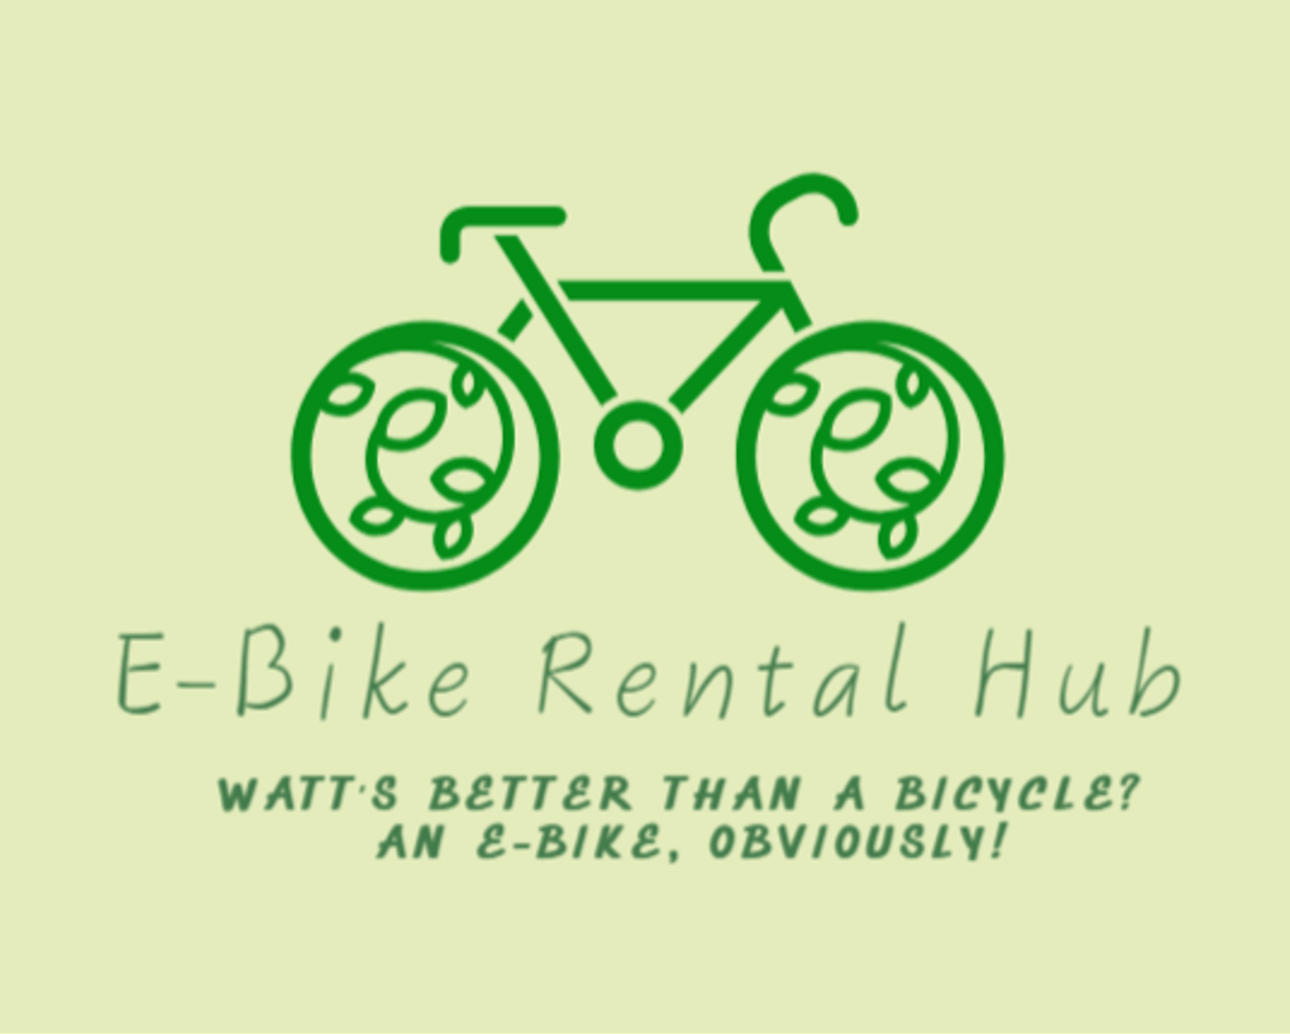

### 

### **Summary**

The E-Bike Rental Hub CRM streamlines the rental process by integrating customer, inventory, and order management into a single platform. It automates billing and inventory tracking, enhancing operational efficiency and customer satisfaction. Built on Salesforce, it is scalable to accommodate business growth while ensuring accurate transactions and improved service delivery, tailored specifically for the e-bike rental industry.